CARD 11
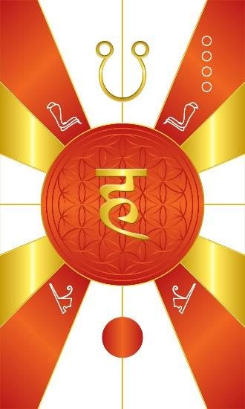
Card 11 is Uatchet, the electropositive end of the magnetic spectrum or magnet. Its colors are Reddish Orange, and it is a psychic energy. In Vedic astrology, it is known as Ketu, the south node of the moon, which is the symbol depicted at the top. Structurally, the top is Yang, so we position the symbol for Ketu at the top to show that it is a Yang energy. Uatchet is a psychic energy that affects the moon within you. This is why in Vedic Astrology, Ketu corresponds to a lunar eclipse. At the bottom, structurally the moon, you see the circular disk is completely dark or obscured, showing that it has been eclipsed. In the middle is the Sanskrit letter for the word of power/mantra or sound “Hang”. In the upper quadrants we have the cobra, the symbol for Uatchet, and at the bottom the red crown of upper Egypt.

Comments by Baba Awodele

